
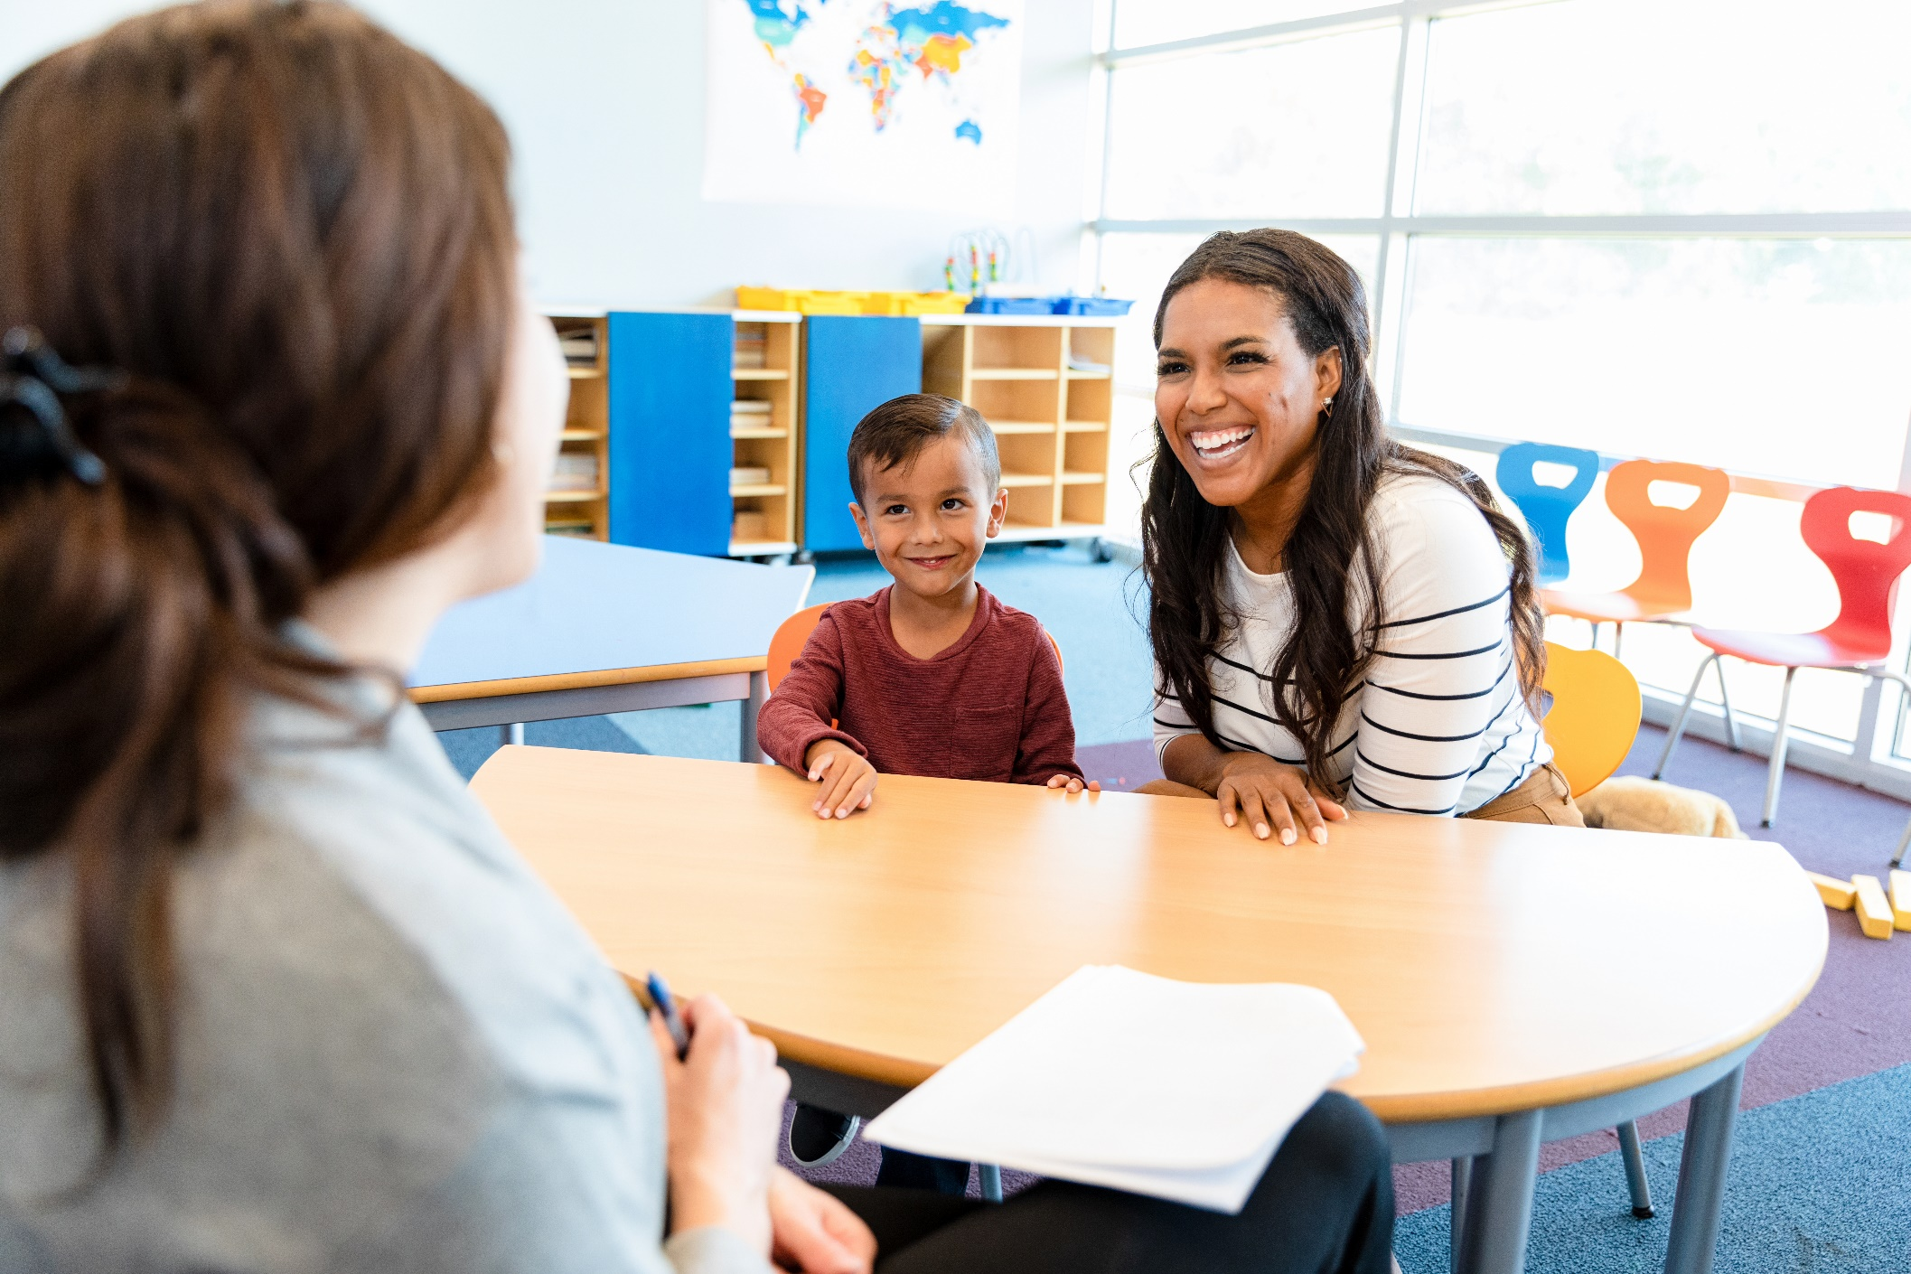
Kindergarten Transition Plan:
A tool for families planning for their chld
EXAMPLE PLAN
Developed by the Ohio Statewide Family Engagement Center
Julie A. Planke and Barbara J. Boone
The journey to kindergarten is a big milestone, and no one knows your child better than you. By planning ahead, you can help make this transition feel smoother and more positive for your child. This plan was created to support families, especially those whose children have disabilities, but it can be used by any family preparing for kindergarten.
You do not need to complete every section or follow the plan exactly as it’s written—this is your plan for your child. Feel free to add, change, or remove parts based on what works best for your child and your family. Use this plan as a flexible guide, personalizing it to fit your child’s unique needs and the resources available to your family. Gathering helpful documents—like a copy of your child’s IEP (if they have one), medical records, and therapy notes—can help you write this plan. Your love and guidance are the foundation of their success, and together with your child's school, you can help make this transition a joyful and positive experience.
Document Overview:
- All About Me (Your Child!)
- Our Strengths (Your Family & Child!)
- Identifying the Kindergarten Transition Support Team
- The Transition Plan
- Communication Plan
- Planning Checklist
- Menu of Kindergarten Transition Practices


Last Updated: 4/18/2025

Suggested Citation:
Planke, J. A. & Boone, B. J. (2025). Kindergarten Transition Plan: A tool for families planning for their child. The Ohio Statewide Family Engagement Center. Retrieved from https://ohiofamiliesengage.osu.edu/.

The contents of this document were developed under a Statewide Family Engagement Center grant from the U.S. Department of Education (Department). The Department does not mandate or prescribe practices, models, or other activities described or discussed in this document. The contents of this presentation may contain examples of, adaptations of, and links to resources created and maintained by another public or private organization. The Department does not control or guarantee the accuracy, relevance, timeliness, or completeness of this outside information. The content of this presentation does not necessarily represent the policy of the Department. This publication is not intended to represent the views or policy of, or be an endorsement of any views expressed or materials provided by, any Federal agency. [89 FR 70333, Aug. 29, 2024]

This plan was adapted from:
Sands, M. M., & Meadan, H. (2022). A successful kindergarten transition for children with disabilities: Collaboration throughout the process.
Early Childhood Education Journal, 50(7), 1133-1141. https://doi.org/10.1007/s10643-021-01246-6

All about me
Child’s Name | Bartholomew (Barry) Smith
Date of Birth | 07/03/2020
Elementary School | New Land Elementary
First Day of Kindergarten | 09/02/2025
Parent/Caregiver 1 & Contact Information | Rachel Williams  email@gmail.com  878-444-5555
Parent/Caregiver 2 & Contact Information | Alexender Smith  email@yahoo.com  917-888-5555



Our strengths
Our Family  - How do you view your role in your child’s education?  - What are you already doing to support your child’s education?  - What are some favorite memories, family traditions, or other things you would like the school to know about your family?  Examples: consistent routines, reading together, eager to collaborate with kindergarten team members, mealtimes, lots of love, etc. | Barry’s mother was a toddler teacher for years before becoming a mom and sees herself as Barry’s first teacher. In addition to his therapies, Rachel provides a consistent daily routine for Barry and activities that Barry enjoys and learns from like singing songs and throwing balls down a ramp.  Barry, Rachel, and his little brother love to celebrate and make the most of every holiday together.  Rachel is looking forward to collaborating with Barry’s new teachers and therapists.
Our Child  - How has your child learned and grown over the past year?  - What can they do well?  - How do they communicate needs?  Examples: empathetic, a natural curiosity, strong imagination, fine motor skills like coloring, developing social skills like sharing or listening, hard worker, etc. | Barry has spastic quadriplegia cerebral palsy and ASD.  In the past year, Barry’s vocalizations have evolved so much! He can sing along to many of his favorite songs and rote counting.  Barry is determined and works hard to accomplish tasks that he is focused on. He engages in adaptive movement well!  Barry is very good at telling someone when something upsets or overstimulates him – he will whine and look for reassurance, such as hand holding.

Kindergarten transition support team
Preschool Staff |  |  | Elementary Staff
Teacher |  | Rachel Williams (Mother) | Kindergarten Teacher | Ms. Ellie Gold
Email/Phone |  | email@gmail.com  878-444-5555 | Email/Phone | email@newland.edu  878-289-2222
 |  | Barry was homeschooled during his PreK years. | Intervention Specialist | Mr. Oliver Lewis
 |  |  | Email/Phone | email@newland.edu  878-289-9999
Director |  |  | Principal | Principal Jackie Griffin
Email/Phone |  |  | Email/Phone | email@newland.edu  878-289-7777
Supports & Services
Ex: Speech, Physical Therapy, Occupational Therapy. Leave blank if none received.
Preschool |  |  | Elementary
Support 1  & Name |  | Speech  Ms. Josephine Brown | Support 1  & Name | Speech  (therapist not yet assigned)
Email/Phone |  | 878-222-4454 | Email/Phone
Support 2  & Name |  | Physical Therapy  Whitney Herbet | Support 2  & Name | Physical Therapy  (therapist not yet assigned)
Email/Phone |  | 878-222-4664 | Email/Phone
Support 3  & Name |  | Occupational Therapy  Debra Angelo | Support 3  & Name | Occupational Therapy  (therapist not yet assigned)
Email/Phone |  | 878-222-1474 | Email/Phone
Notes & Additional Service Providers
Barry also received feeding therapy in Early Intervention from age 2-3 (he currently eats a primarily puree diet)

Reminders | You are your child's strongest advocate and most important team member in their journey to kindergarten!  If your child did not attend preschool, skip those sections but note any Early Intervention services and other important details (if received).

The transition plan
Child’s Need |  | IEP Goal(s)  If applicable | Related Transition Activities/Strategies | Who’s Responsible?
1. | Mobility support in the classroom | Improve independent movement | Schedule a visit or two before kindergarten starts. Ensure pathways are clear, provide seating accommodations as specified by Barry’s mother, and train staff on using Barry’s mobility aids (stander, walker, wheelchair) | Intervention Specialist, OT/PT
2. | Support for sensory regulation | Regulate sensory needs | Environmental modifications - sometimes Barry needs more or less sensory stimulation. Based on his vocalizations, turn on a favorite song or move to a quiet space if needed. | Intervention Specialist
3. | Support during transitions | Transitions between activities | Use transition cues such as music, singing, and dancing or provide Barry’s comfort object (his lion lovey) | Intervention Specialist, OT/PT/Speech
4.
5.
- The supports your child needs to be successful in school can often be understood through the concerns you notice or share. You may also know what types of supports help your child to be successful.
  - Examples: If your child has difficulty changing from one activity to the next, visual supports and verbal reminders may help make transitions smoother. If your child struggles to sit during mealtimes, you can plan to model lunchtimes together over the summer months. If your child uses adaptive equipment, you can plan a meeting with their new school to ensure that staff understand how to support their use.
- By working together with your child’s teacher, you can find the best ways to support your child.
- For more ideas, check out the Menu of Kindergarten Transition Practices on the last page!

Communication plan
This plan is designed to be flexible and change over time to meet the needs of your child and family. After each conversation, take a moment to check in and make sure everyone is on the same page to best support your child’s transition.

Scheduled | Date/Time | Who’s Communicating?
Transition Planning Meeting | 8/15/2025 2 PM on Zoom | Barry’s mother and the classroom Intervention Specialist
Visit to Classroom | 8/18/2025 9 AM | Barry, Barry’s mother and teachers
Parent Teacher Conference | 9/26/2025 3PM  (Spring Conference TBD) | Barry’s mother and teachers
Meetings w/ new therapists | TBD | Barry’s mother, new OT provider, new PT provider, new speech provider
Ongoing | Frequency  Daily, Weekly, Monthly, etc. | Who’s Communicating?
Home-School Notebook | Daily | Barry’s mother and the classroom Intervention Specialist
Phone Call | Weekly | Barry’s mother and the classroom Intervention Specialist
Texts | As needed | Barry’s mother and the intervention specialist and/or Barry’s therapists
Please check off your preferred way of ongoing communication:
- Phone call
- Text message
- Email
- Other: _______________

Planning checklist
- Appropriate transition activities have been selected and scheduled in this Transition Plan

- All kindergarten transition team members have received a copy of this Transition Plan

- All kindergarten transition team members have received a copy of the child’s current IEP (if applicable)

Additional Notes:
Ensure all staff are familiar with cerebral palsy and Barry’s specific needs. Barry is allergic to dairy and corn and should only eat the food provided by his mother. Barry can feed himself his snacks but requires help eating pouches.
Socially, Bartholomew interacts very well with familiar adults. He generally prefers to play alone but not all the time. Barry will initiate play. He enjoys throwing balls and toys, climbing familiar furniture, playing with familiar toys, spinning toys, bells, and musical toys. When Barry gets tired, he likes to watch TV with his lion lovey and water bottle. He loves singing familiar songs together and cuddling.___________________________________________________
______________________________________________________________________

______________________________________________________________________
______________________________________________________________________

menu of Kindergarten transition practices
Use this menu to help find helpful ways to support your child’s needs as they transition into kindergarten. This is not a complete list - the possibilities are endless! Every child is unique, and you know your child best. Feel free to adapt these ideas and create your own too.

Preschool & Early Preparation
- Read books about kindergarten and talk about what to expect.
- Practice self-help skills such as using the bathroom, opening lunch containers, and following simple directions.
- Visit the school’s website to look at pictures of the classroom, teachers, and school spaces.
- Introduce sensory-friendly school supplies (Ex: noise-canceling headphones, weighted lap pads) if helpful.
- Encourage your child’s preschool teacher to talk about kindergarten routines in class to build familiarity.
- Schedule an individual transition meeting with preschool staff before the last day of school to discuss your child’s strengths and needs (use this plan to help!) This transition meeting is especially important if your child does not have IEP meetings.
- Ask for meetings with your child’s therapy team (Ex: OT, PT, Speech) to develop school-readiness goals.
- Seek early intervention services or additional support if your child has specific needs.
- Arrange playdates with preschool friends who will attend the same kindergarten (a “buddy system”).

The Summer Before Kindergarten
- Attend school-sponsored kindergarten orientations or open house events.
- Take a walk or drive by the school to help your child get familiar with the location.
- Practice transitioning between activities at home to support flexibility.
- Talk about making new friends and role-play introducing themselves to classmates.
- Begin a morning routine that will match your child’s kindergarten schedule. Practice waking up at the same time, getting dressed, and doing activities like packing their backpack.
- Visit the playground at the kindergarten school to help your child feel more comfortable.
- Ask preschool and kindergarten teachers to work together to make sure they have the same expectations for your child (Ex: email both teachers to get their conversation started).
- Schedule an individual meeting with the kindergarten teacher before school starts (if possible) to discuss your child’s strengths and needs and write this plan together.
- Request a meeting with the special education team to ensure any necessary accommodations are in place before school starts.
- Arrange a private school visit for your child to explore their classroom, meet their teacher, and get comfortable in the space.
- Enroll your child in a kindergarten readiness program or summer camp.
- Introduce visual schedules, timers, or first-then boards if your child benefits from structured routines.
- Connect with other kindergarten families through school-organized groups or social media.
- Work with a speech therapist or other specialists to create a social script for making friends and communicating needs in school.

Starting Kindergarten
- Meet with your child’s new educational team if you have not yet to continue to write and share this transition plan.
- Read teacher welcome letters or watch any school introduction videos.
- Establish a consistent morning and drop-off routine to best support your child through this transition.
- Give your child a comfort item to bring to school (if allowed) to give them some reassurance during the school day (Ex: a favorite stuffed animal or action figure).
- Talk about school rules at home and practice them through play.
- Help your child learn classmates’ names and encourage them to reflect or talk about their day by asking specific questions.
- Create a communication plan to support your child’s transition (page 6).
- Talk with the teacher about flexible seating options (Ex: wobble stools, cushions, standing desks) to support sensory and motor needs.
- Explore different ways to help your child communicate, like picture boards, speech devices, or simple sign language, if they don’t use many words to talk.
- Work with school staff to arrange additional supports as needed (Ex: buddy system, additional check-ins).
- Attend early parent-teacher meetings to discuss strengths and concerns.

Additional Ideas:
Use Barry’s comfort object (his lion lovey) to support him.__________________________

______________________________________________________________________
______________________________________________________________________

______________________________________________________________________

