2025 Family Leaders for Ohio Schools Academy Application
Deadline: October 25, 2024

What is Family Leaders for Ohio Schools Academy?
The Ohio Statewide Family Engagement Center has designed a free five-month program to help families become more involved in their child’s school and understand Ohio’s education system. Participants will connect with others, build leadership skills, and design and implement a project to address a need in their school community.

Who can apply?
Any parent, guardian, or caregiver of a child enrolled in an Ohio public school (K-12) who is committed to equity and excellence for all students.
How many participants?
30

When?
The program runs January-May 2025

Program Details:
Participants will attend in-person and online meetings, complete learning modules with independent assignments, and present a local school project.

- January 24: In-person kickoff (10:00am-3:00pm) Columbus, Ohio
- January 25-February 20: Complete module
- February 21: Online meeting (8:30am-10:00am or 11:30am-1:00pm)
- February 22-March 6: Complete module
- March 7: In-person meeting (10:00am-3:00pm) Columbus, Ohio
- March 8-April 24: Complete module
- April 25: Online meeting (8:30am-10:00am or 11:30am-1:00pm)
- April 26-May 15: Complete module
- May 30: Celebration and project presentation (10:00am-12:00pm) Columbus, Ohio

Attendance Policy:
By applying, you commit to attending all activities. If these dates and times do not work for your schedule, please consider applying next year.
*This program is funded by a grant from the U.S. Department of Education. If accepted, participants will receive a small stipend for attending all meetings and mileage reimbursement for travel to meetings in Columbus, OH.

First Name: _________________________ Last Name: ___________________________
Address: ________________________________________________________________
City: _____________________ Zip Code: _________ Ohio County: __________________
Email Address: __________________________________ Phone: (____) ______________
Are you employed by The Ohio State University or by a preK-12 public or private school?
Yes __ No __
What is your race/ethnicity? (Select all that apply)
- American Indian or Alaskan Native
- Asian
- Black or African American
- Hispanic or Latino
- Middle Eastern or North Africa
- Native Hawaiian or Pacific Islander
- White
- Other _______________
- Prefer not to answer
Parent/Caregiver Relationship. (Select all that apply)
- Biological Parent
- Grandparent Caregiver
- Foster or Adoptive Parent/Caregiver
- Guardian
- Other, please explain ______________________
How did you hear about this opportunity? (if applicable, provide the name of the person who shared it with you) ___________________________________________________________
Current Occupation(s) _______________________________________________________
Current Grade of your child/children for 24/25 school year (please list all):
__________________________________________________________________________
Name of Public School/s and School District your child/children attend:
___________________________________________________________________________
Short Answer Questions
Directions: Please type/write responses after each question below. Please make sure you answer all four questions before submitting.

- How are you currently involved in your child’s school or in your community?

- What motivated you to apply for this opportunity?

- What do you hope to gain from this experience?

- What questions do you have about the program?

Submission Instructions

Please submit your application by October 25, 2024

- Online Version: https://go.osu.edu/familyleadersacademy
- Email: OhioSFEC@osu.edu (Subject: FLOSA Application)
OR
- Mail to: Ohio Statewide Family Engagement Center (Attn: Kristin Meek-Hennon)
1900 Kenny Road, Suite 1036, Columbus, Ohio 43210
We will inform applicants via email by November 29, 2024.

Thank you for your application!

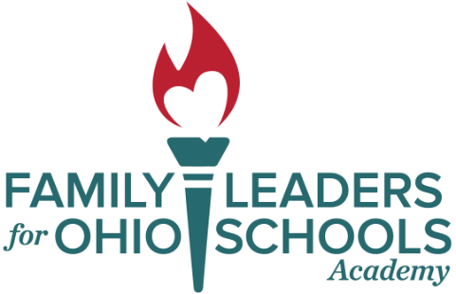

For more information, visit our website https://ohiofamiliesengage.osu.edu/

