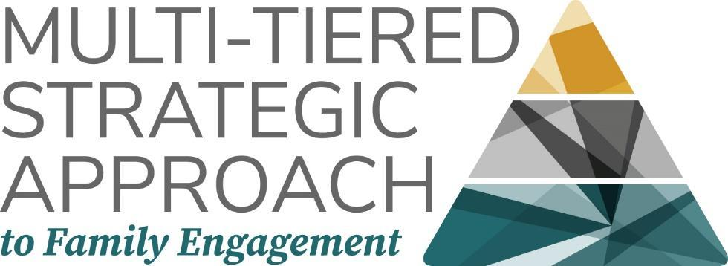

Family Engagement Plan for: (Describe the situation/initiative that is the basis for the plan: What is it, and how long is the timeframe?)

What is the measurable goal for students?

How will students benefit if we achieve this goal?

How will families benefit if we achieve this goal?

How will school personnel benefit if we achieve this goal?

Tier I: Universal for All Families
Tier I supports are universal, school or program-wide strategies accessible to all families.

Part A: Center Families

What do all families need to support this goal?

What do all families want to support this goal?

What strengths do all families have in support of this goal?

Other notes:

Part B: Universal School/Organization Strategies

What can the school/organization do to meet the universal family needs in support of this goal?

What can the school/organization do to meet the universal family preferences in support of this goal?

How can opportunities be created to build on universal family strengths?

Check: are all roles available universally to families at this level of your plan?
- Providers:
- Receivers:
- Initiators:
- Co-Designers:
- Evaluators:

Part C: Indicators for a Change of Tier

What might indicate a need for a change of tier for some families?

- Check: Are your Tier I Practices universal enough? Will they meet the needs and preferences of at least 80% of families?

Tier II: Tailored for Groups of Families
Tier II supports include programs and strategies for groups of families with shared needs, interests, or talents for additional, deeper support or engagement. (e.g., families of students with disabilities, military families, etc.)

Part A: Center Families

What do some groups of families need to support this goal?

What do some groups of families want to support this goal?

What strengths do some groups of families have in support of this goal?

Other notes:

Part B: Tailored School/Organization Strategies

What can the school/organization do to meet the needs of groups of families in support of this goal?

What can the school/organization do to meet the preferences of groups of families in support of this goal?

How can opportunities be created to build on the strengths of groups of families?

Check: are all roles available to groups of families at this level of your plan?
- Providers:
- Receivers:
- Initiators:
- Co-Designers:
- Evaluators:

Part C: Indicators for a Change of Tier

What might indicate a need for a change of tier to Tier III for individual families?

- What might indicate that groups of families no longer need Tier II strategies?

Tier III: Intensive for Individual Families
Tier III supports are available to provide additional resources, assistance, and highly intensive opportunities for individual families who require engagement supports or opportunities beyond Tier II. (e.g., A parent with expertise in the area of the initiative, a family of a child with a serious illness, etc.)

Part A: Center Families

What do individual families need to support this goal?

What do individual families want to support this goal?

What unique strengths do individual families have in support of this goal?

Other notes:

Part B: Intensive School/Organization Strategies

What can the school/organization do to meet the individualized needs of families in support of this goal?

What can the school/organization do to meet the individualized preferences of families in support of this goal?

How can opportunities be created to build on the unique strengths of individual families?

Check: are all roles available to individual families at this level of your plan?
- Providers:
- Receivers:
- Initiators:
- Co-Designers:
- Evaluators:

Part C: Indicators for a Change of Tier
- What might indicate that individual families no longer need Tier III strategies?

