Jigsaw Breakout Directions
Purpose: Encourage discussions in a smaller setting.

Roles: Timekeeper, Notetaker, Speaker

Process:
- Decide who will do the roles for the Jigsaw.
- Read selected part of the text. The timekeeper needs to keep track of the times to read and discuss.
- Together, discuss the text and have the notetaker record the group thoughts on the row in the notecatcher.
- Return to the whole group and have the speaker report a summary of your discussion to the whole group.
- Synthesize ideas.

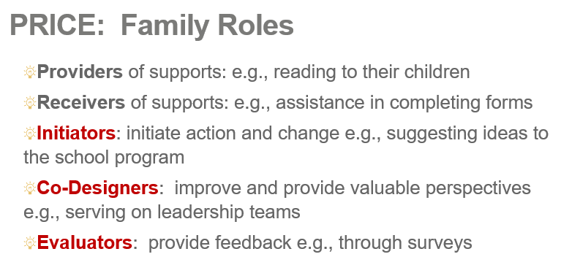

Overcoming Barriers to Participation in Out-of-School Time Programs Jigsaw Notecatcher
https://www.nova.edu/projectrise/forms/improving-attendance-retention.pdf
Kennedy, E., Wilson, B., Valladares, S., & Bronte-Tinkew, J. (2007). Improving attendance and retention in out-of-school time programs. Research-to-Results Practitioner Insights Child Trends, 17.
Barrier | What can programs do?  (record at least 2) | How could families engage in PRICE roles to address the barriers?  (record at least 2)
Safety, Transportation and Cost
Family Responsibilities
Desire or Need to Work
Lack of Identification with Staff Members
Lack of Interest in Organized Activities

