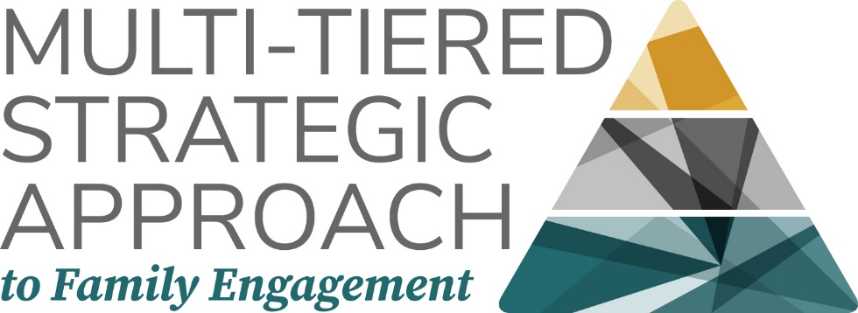

Family Engagement Plan for: (Describe the situation/initiative that is the basis for the plan: What is it and how long is the timeframe?)

What is the measurable goal for students?

How will students benefit from this situation/initiative?

How will families benefit from this situation/initiative?

How will school personnel benefit from this situation/initiative?

Tier I: Universal for All Families
Tier I supports are universal, school or program-wide strategies accessible to all families.

Part A: Family needs/opportunities

What personal motivators do all families have to engage in this situation/initiative?

What knowledge and skills do all families bring to engage in this situation/initiative?

What concerns and questions will all families have?

What information and resources will all families want?

Part B: School Response/Supports

How can you provide opportunities for families to be initiators in this situation/initiative?

What opportunities can be provided for all families to share their knowledge and skills as co-designers and providers?

How can opportunities be created to listen to families as evaluators?

How can information and resources be provided to families to support their role as receivers?

Part C: Indicators for a Change of Tier

What might indicate a need for a change of tier for some families?

- Check: Are your Tier I Practices universal enough? Will they meet the needs and preferences of at least 80% of families?

Tier II: Tailored for Groups of Families
Tier II supports include programs and strategies for groups of family with shared needs, interests, or talents for additional, deeper support or engagement. (e.g., families of students with disabilities, military families, etc.)

Part A: Family needs/opportunities

What personal motivators do groups of families have to engage in this situation/initiative more intensely, frequently, or differently?

What knowledge and skills do groups of families bring to engage in this situation/initiative more intensely, frequently, or differently?

What concerns and questions will some groups of families have?

What information and resources will some groups of families want beyond those provided at Tier I?

Part B: School Response/Supports

How can you provide opportunities for groups of families to be initiators in this situation/initiative more intensely, frequently, or differently?

What opportunities can be provided for groups of families to share their knowledge and skills as co-designers and providers more intensely, frequently, or differently?

How can more intense, frequent, or different opportunities be created to listen to some groups families as evaluators?

How can information and resources be provided beyond Tier I level to some groups of families to support their role as receivers?

Part C: Indicators for a Change of Tier

What might indicate a need for a change of tier to Tier III for individual families?

- What might indicate that groups of families no longer need Tier II strategies?

Tier III: Intensive for Individual Families
Tier III supports are available to provide additional resources, assistance, and highly individualized opportunities for very few families who require engagement supports or opportunities beyond Tier II. (e.g., A parent with expertise in the area of the initiative, a family of a child with a serious illness, etc.)

Part A: Family needs/opportunities

What personal motivators do individual families have to engage in this situation/initiative more intensely, frequently, or differently?

What knowledge and skills do individual families bring to engage in this situation/initiative more intensely, frequently, or differently?

What concerns and questions will certain individual families have?

What information and resources will certain individual families want beyond those provided at Tier II?

Part B: School Response/Supports

How can you provide opportunities for individual families to be initiators in this situation/initiative more intensely, frequently, or differently?

What opportunities can be provided for individual families to share their knowledge and skills as co-designers and providers more intensely, frequently, or differently?

How can more intense, frequent, or different opportunities be created to listen to certain individual families as evaluators?

How can information and resources be provided beyond Tier II level to certain individual families to support their role as receivers?

Part C: Indicators for a Change of Tier
- What might indicate that individual families no longer need Tier III strategies?

