Encouraging Positive Behaviors at Home

At school, we have a few simple ideas we use to guide how we all work together, both children and adults. We call these our expectations. These expectations guide how we act and talk with each other in every part of our school building and school day. These same expectations can be useful at home. You might find this type of chart useful to help guide your child’s positive behavior at home. Using the chart below, you and your child can create your own, personalized chart with expectations for how your family will care for each other at home. Though this chart could be used with children of any age, the example chart was written with elementary and middle school children in mind.

Directions: Add your school’s behavior expectations, and/or your family’s expectations, in the first column. Decide which places or times of day you want to focus on. It’s a good idea start with a time of day when your child is already behaving well. For example, if your child is pretty good at following your expectations in the morning, focus on that time first. Talk to your child about what it looks like to follow the expectations at home. Every family’s expectations might be a little different, and that’s okay! Give your child examples to get them started and share your own, too. Take your time and go through each expectation one at a time. Then, talk through other times of day, like mealtimes, when you are at the grocery store, or at bedtime. Write what you and your child decide are good behaviors in each box at various times of the day. It is best to stick to 1-3 behaviors in each box. The example on page 3 will give you some ideas for how to use the chart. A blank chart is on page two for you to use with your family. Consider sharing your family’s chart with your child’s teachers so they know how you are supporting positive behaviors at home!

This document was created by the Ohio Statewide Family Engagement Center with the Ohio Family and Community Engagement Network and the Ohio Department of Education’s PBIS Network. Visit OhioFamiliesEngage.osu.edu for more tools to launch student success through closer family-school-community partnerships!
The _______________________ Family’s
Positive Behaviors Chart

Write in your expectations below | Time  (Use the times and places below or write in your own.)
 | Morning | Mealtimes | Bedtime | Out in the Community

The Example Family’s Positive Behavior Chart

Write in your  expectations below | Time
(You may use your school’s expectations to get started) | Morning | Mealtimes | Bedtime | Out in the Community
Be Respectful | Say “Good Morning”  Good  Morning! | Sit at table to eat | Get in bed on time  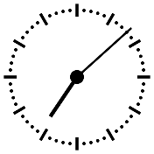 | Wait for your turn  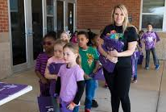
Be Responsible | Wash hands  before meal | Clean up your area  when finished | Brush your teeth | Stay with an adult  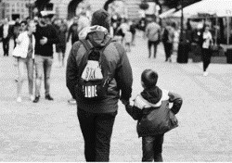
Be Safe | Walk on sidewalk to  meet the school bus | Be careful using  sharp utensils | Pick up toys  off the floor | Look before  crossing the street

