Career Exploration

Note to parents and caregivers:
This activity is meant to help you talk through possible career options and interests.
Work through the activity together and answer the questions asked throughout.
Let your child attempt to answer the questions first and provide them with help or suggestions as needed.

Part I. Make a list:
Quick -- fill in each column with careers you’d LOVE to have when you are an adult and careers you’d HATE to have.
LOVE IT! | HATE IT!

Part II. Article: 5 Factors to Consider When Selecting a Career
Picking a career is a big decision, and there are MANY things you can consider. Read this article to learn about 5 main points you should think about and then answer the questions.

5 Factors to Consider When Selecting a Career

If you’re looking for a short-term or part-time job, you can make just about anything work. But, when you’re trying to select a career path, you should ask yourself these 5 questions to improve your chances of loving your career:
- Do I have the skills, experience, and education? Maybe you are a natural, but it is more likely you will need to work to develop the skills and expertise to be truly good at your future career. If you don’t have the proper preparation, you will struggle to do your work well.
- Am I passionate about the work? It will be easier to go to work and really thrive if you are passionate about your job and the impact that you are making.
- Will I have the lifestyle that I want? Different careers have different expectations for work-life balance. For example, will you have to work nights, weekends, or holidays in this job? Does this career require travel? Do you have the flexibility to work remotely?
- What is the salary and earning potential? Before choosing a career, you should know the average starting salary and how much of a chance you will have for raises and promotions. You will also want to know about other benefits like health care and retirement funds.
- What is the culture like? Some careers are fast-paced and competitive, while others may value teamwork and commitment to the mission. Learn whether your personality will fit the industry before deciding this is the career for you.

The average American changes jobs many times over the course of their lives, but considering these 5 factors will help you find the profession that is right for you.
Source

Whitney absolutely loves animals, so she is considering a career as a National Park ranger. She clearly has the passion. Provide an example of another factor from above that she should consider and why it might be important before she makes a final decision.

Should you consider these career factors before, during, or after attending college or alternative training? Explain your thinking.

Part III. Data Crunch: Starting and Median Salaries for Two Careers
When determining salary and earnings potential, there are two frequently used terms to understand:
- The first year of your career in a new profession, you make what is called a starting salary, which will likely be much lower than the average salary for everyone working in that profession. Most careers pay more to experienced employees than they do to new workers.
- The median salary for a profession is the middle of the payscale for people doing that job -- half of workers make less than the median salary, while half of workers make more than the median.
Learn more about salary and earning potential by studying graphs from two careers on the next 2 pages -- Social Worker and Mechanical Engineer.

Social Worker
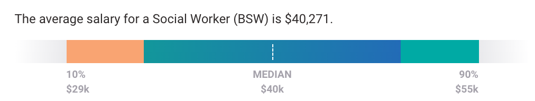
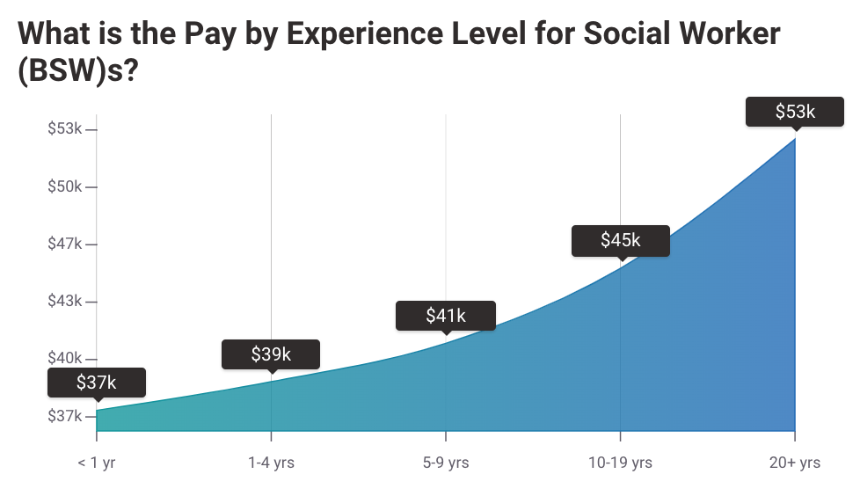
Source

What is the starting salary for a social worker?

What is the median salary for a social worker?

How many years does the average person work as a social worker before earning the median annual salary?

Would you say social workers have great earning potential? Why or why not?

Mechanical Engineer
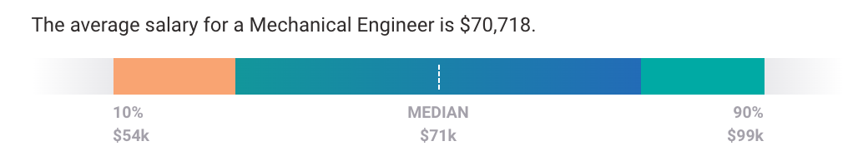

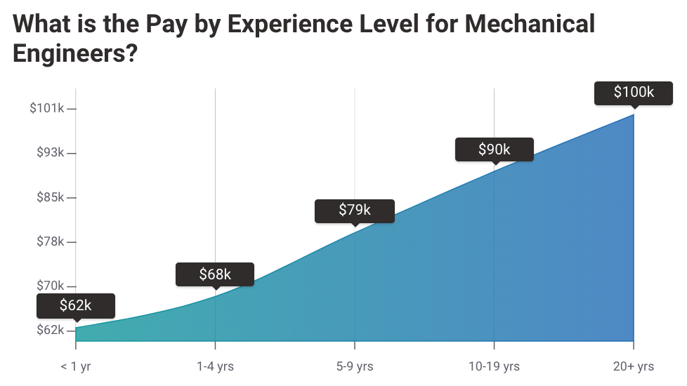
Source

What is the starting salary for a mechanical engineer?

What is the median salary for a mechanical engineer?

How many years does the average person work as a mechanical engineer before earning the median annual salary?

Would you say mechanical engineers have great earning potential? Why or why not?

Part IV. Interactive: Career Cluster Inventory

Click on the link to complete a career cluster inventory. You can also copy and paste the link or type it into your browser.
https://jobseeker.k-12.ohiomeansjobs.monster.com/ExploreIt/DefaultCci.aspx#/welcome

Answer the questions on this career search tool honestly. It’s quite long and might take 10-15 minutes to complete, but at the end, it will recommend which types of careers might be best for you.

Which Career Cluster, located at the top of your results page with the highest score, did the career inventory recommend?

Now, click on your recommended Career Cluster, and then use the Career Pathways buttons on the left to reveal jobs in this Cluster. After reviewing a few of the jobs, does this Career Cluster seem like a good match for you? Why or why not?

Choose any one job recommendation and click the job title link to explore that job more deeply. Now, complete this table by entering a ✓ to assess how well this particular job fits your factors for a desirable career.

Recommended Job I’m Assessing:

Factor | This is a great fit for me | This is an OK fit for me | This is a bad fit for me | Not enough detail to assess
Skills, experience, education
Passion

Lifestyle

Salary & earnings potential
Culture

Part V. Talk about it:

What, if anything, do the jobs you’d LOVE to do have in common?

What are some of the limitations of using a career inventory during middle school to help you choose a job?

Why is it important to consider not just the starting salary for a given job but also how much you might earn over your entire career?

Name one potential danger of choosing a career based solely on salary and earnings potential.

Note: This activity was adapted with permission from the NextGen Personal Finance Middle School Course MS-9.4.

