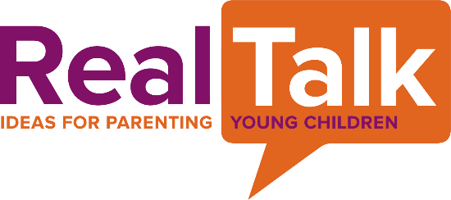
Resources for Talking with Children about Diversity, Race, and Inclusion
Websites for Parents/Caregivers
- https://ohiofamiliesengage.osu.edu/2021/07/15/early-childhood-is-a-great-time-to-learn-about-race-equity-and-inclusion/
- https://ohiofamiliesengage.osu.edu/2020/07/20/video-talking-to-your-kids-about-race-racism/
- http://www.aldenhabacon.com/13-tips-how-to-talk-to-children-about-diversity
- https://www.scholastic.com/teachers/articles/teaching-content/teaching-diversity-place-begin-0/
- https://www.parents.com/kids/responsibility/racism/teaching-diversity-to-your-kids/
- https://www.unicef.org/parenting/talking-to-your-kids-about-racism
- https://www.healthpartners.com/blog/teach-them-to-embrace-diversity/

Books for children
Celebrate the World Series (board books)
Lunar New Year, Ramadan, Cinco De Mayo
Last Stop on Market Street Marisol McDonald Doesn’t Match
By Matt De Pena By Monica Brown
All are Welcome Hot Hot Roti (Indian food)
By Alexandra Penfold By F. Zia
King of The Classroom I Love My Hair
By Derrick Barnes By Natasha Anastasia Terpley
Quinito’s Neighborhood Gracias * Thanks
By Ina Cumpiano By Pat More
A morning with Grandpa In a Village by the Sea
By Sylvia Liu By Muon Van
Pink is for Boys Robb Pearlman
Heather has Two Mommies Leslea Newman
Uncle Bobby’s Wedding Sarah S. Brannen
Please, baby, please Spike Lee & Tonya Lewis Lee
Happy in Our Skin Fran Manushkin
Hair Love Matthew A. Cherry
More More More Said the Baby Vera B. Williams
Bippity Bop Barbershop Natasha Anastasia Tarpley
Dad, Who Will I be? G. Todd Taylor
Skin Like Mine Latasha M. Perry
I Am Enough Keturah A. Bobo

