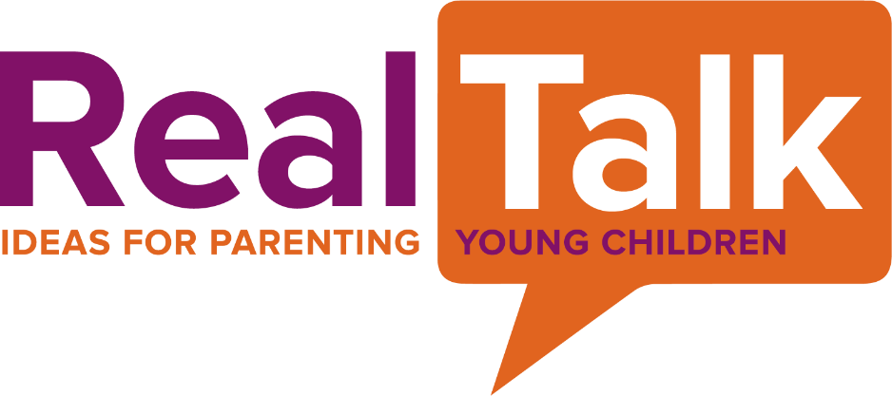

Let’s be honest: parenting young children can sometimes be hard. That’s why we asked OSU early childhood experts to weigh in on the most common topics that families ask for help navigating in this RealTalk webinar series. Whether you are a father, mother, uncle, grandparent, or other parenting adult, join us for a 30-minute live session packed with information, top tips, and a chance to ask questions. Or watch the recording at a time that works best for you.

• • • • •

Upcoming RealTalk Webinars
Visit https://ohiofamiliesengage.osu.edu/realtalk for full details, to join the webinar, or to see previous recordings.

Transitioning your child into kindergarten
Wednesday, May 26 • 12:30-1pm • Zoom
Starting kindergarten is a big and important transition for your child. Learn about the enrollment process, what to expect, and ways to help your child get ready for this big change.

Loving with limits: Effective guidance and discipline strategies for young children
Wednesday, June 23 • 12:30-1pm • Zoom
Do you find yourself dreading mealtimes, bedtime, or morning routines with your young children? Hear tips and strategies that work with children of all ages to set consistent limits, avoid power struggles, and increase compliance.

Navigating sibling rivalry and conflict resolution with kids
Wednesday, July 28 • 12:30-1pm • Zoom
Families must often cope with and mediate conflicts between siblings of all ages. Learn why conflicts occur, when to support children, and how to set siblings up for less conflict.

• • • • •

This series is free and open to all. Registration is not required. Use the link below to join a session:
https://go.osu.edu/realtalk

• • • • •

The RealTalk series is presented in partnership by the Ohio Statewide Family Engagement Center and the
A. Sophie Rogers School for Early Learning at The Ohio State University.

