Preparing for High School

Note to parents and caregivers:
This handout includes various links to videos and resources you can access together to help your middle schooler prepare for High School. Work through the activity together and make sure to have your middle schooler respond to the questions asked throughout the activity.

Part I. Discussion: What would you do?
Pretend you are assigned a new project. You have to fold 1000 origami animals, by next week, and you aren’t given you any materials. You get to choose 5 people to be on your team.

What qualities would you look for as you select your group members?

Part II: What Do Colleges Look For?
Watch the video using the following link to learn about what colleges look for. You can click on the link below or copy the link or type the link into your internet browser. Be prepared to answer some questions after watching the video. https://edpuzzle.com/media/5ec2f9c9f020e63f5e9a50ee

In the first part of this worksheet, you determined what characteristics would help you choose the best people to add to your team member to work in your origami group. College admissions counselors do the same thing -- figure out what matters most when it comes to admitting new students and then assessing which applicants are strongest.
- Which two questions are colleges trying to answer by looking at your transcript?
  - Did you take challenging courses?
  - Were you involved in clubs and/or sports?
  - Did you earn good grades?
  - Were you class president or otherwise a leader?
- What is the difference between a college essay and a recommendation letter?
  - The essay is written by the student, and the letter is written by an adult
  - The essay is written by an adult, and the letter is written by the student
  - The essay describes everything on your transcript, and the letter is about your personality.
- How will being involved in extracurricular activities also help your college essay and/or recommendation letters?
  - If you fill your college application with enough extracurriculars, you won't have to write the essay
  - Extracurricular activities are after school clubs where you can write the essays and letters you need
  - You'll have interesting experiences and make connections with adults who can write recommendations

Part III. Read the article: What’s a High School Transcript?
Many of the items from the College Admissions video come into play the second you enter high school, so it is important to go in with a plan. The first step is understanding terms such as transcript and GPA.

What’s a High School Transcript?

Your high school transcript is a complete record of your academic achievements in high school. It starts with the first grading period of your first year of high school and is updated each term until you graduate.

The format varies from school to school, but most transcripts include:
- Your name, address, and date of birth
- The name of your school
- The courses you’ve taken and when you took them
- Your grades for each grading period
- The weight of each grade (grades in higher-level courses like AP are often worth more than the same grade in a standard course)
- The number of credits you earned for each course
- Your GPA calculated with all of the courses you’ve taken so far
- Your scores on AP Exams, the SAT, or other standardized tests
- Any academic honors you’ve received

High school transcripts are necessary for almost every college application. Some scholarships, internships, and jobs may also ask for a copy of your high school transcript.
Source

Part IV. Review definition: GPA

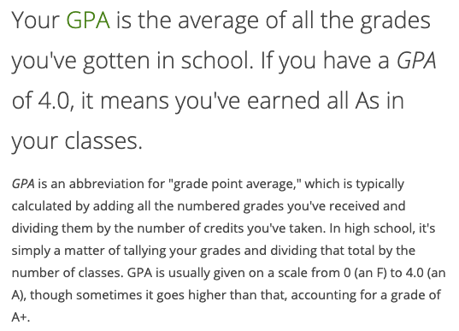Source

How is a transcript different from a report card?

Kelvin’s in grade 9 and figures he can wait until the start of 11th grade to worry about his GPA. Why is that a bad idea?

Why do you think colleges rely so much on student transcripts when deciding who to admit?

Part V. Watch the video: What’s the Difference Between Honors, AP, and IB Classes?
You can click on the link, copy and paste, or type the link into you web browser.
https://www.youtube.com/watch?v=BmPLuJD11TA

By taking challenging coursework during high school, you’ll prove to admissions officers that you are willing to work hard on your studies.
- Jasmine struggles in some of her middle school classes, even though she tries really hard. She needs to choose courses for 9th grade. What do you think is her best option:
  - Option A: Register for all Honors/AP courses, even if she risks a low GPA
  - Option B: Register for mostly regular courses and 1-2 high level courses, and earn a middle-level GPA
  - Option C: Register for all regular courses, and earn a high GPA

- Explain your answer.

- Do you know which, if any, of these course types your high school offers?

Part VI. Planning for High School Success
High school is a time for learning a lot and having new experiences. Some of the same factors that colleges look for will also be important for getting your first job or creating other opportunities. It’s never too early to plan for the future! Complete the 4-Square worksheet below to get started.

Part V. Talk about it

How might the 4-Square you just created help you as you transition to high school?

Which document outlines your courses and grades throughout all of high school?

Why do colleges want to see that you took challenging courses in high school?

What are two reasons it is important to be involved with organizations or hobbies outside of just school work?

Note: This activity was adapted with permission from the NextGen Personal Finance Middle School Course MS-8.1.

