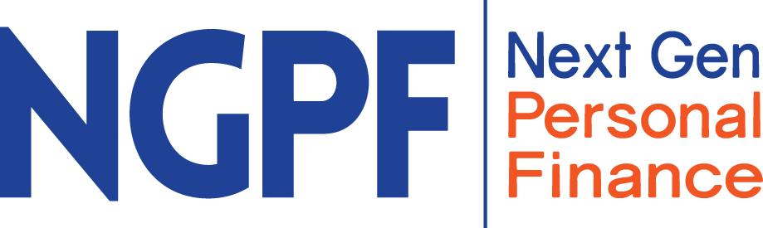

Savings vs. Checking Accounts
Note to parents and caregivers:
First, you will be asked to read through the article below that explains what a savings account is. After reading the article, discuss the questions that are in the “Talk about it” section. After that, there is an infographic you and your child can review together. Please note that there is a link you can click on to see a larger version of the infographic. Work together to answer the questions in the final section that are based on the information shared throughout the activity. Try to let your child attempt to answer the questions first and provide them with help or suggestions as needed.

Part I: Warm-up question

Discuss the following question before reading the article.

Why do you think it’s a good idea to have your money for savings in a different account than your checking account?
Part II: Read the article

What is a Savings Account?
What is a savings account and why do people use them? Read this article below to learn more about savings accounts and then answer the questions.

What is a Savings Account?

A savings account is a place where you can store your cash safely while earning interest.

- Why you need a savings account: A savings account lets you put money aside that you don’t need immediately, but may need at some time in the future. For example: a vacation, an item you have been wanting to buy, or to cover the costs of an emergency.
- You earn interest: The money in your savings account earns interest - so your money can make more money! (Note: Checking accounts occasionally earn interest too, but at much lower rates.)
- You can’t use the money in your savings account as often: Unlike a checking account, a savings account is used for purchases you don’t make very often. In fact, by law you can only transfer or take out money from your savings account up to 6 times per month! Otherwise, you will have to pay a fee.
- FDIC insured: When opening a savings account, it’s important to check if the account is FDIC insured (most are). FDIC insured means that the federal government will insure up to $250,000 of the money in your account in case the bank fails.
- Online-Only accounts: An online-only savings account means there is no physical bank or credit union where you can go to access your money and deposit, transfer, or take out cash. Instead, everything is done online or through your smartphone app. Online savings accounts usually have higher interest rates than traditional savings accounts, because they do not have to pay the costs that come with maintaining a physical building. If you want to deposit cash into your online-only savings account, you would need to deposit it into a checking account and then transfer it into your savings account.

Savings accounts are a great way for you to put money aside for your “future self”!

Source

Part III. Infographic:
What’s the Difference Between Checking and Savings Accounts?

Click on the link below for a larger version of the infographic
https://bettermoneyhabits.bankofamerica.com/en/personal-banking/the-difference-between-checking-and-savings-account

Checking and savings accounts are both important tools for managing your money, but they are used for very different purposes. Read through this infographic to learn about how these accounts are different. Then, answer the questions.
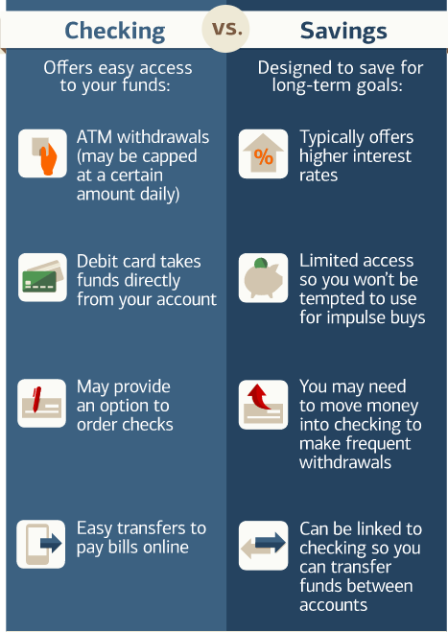
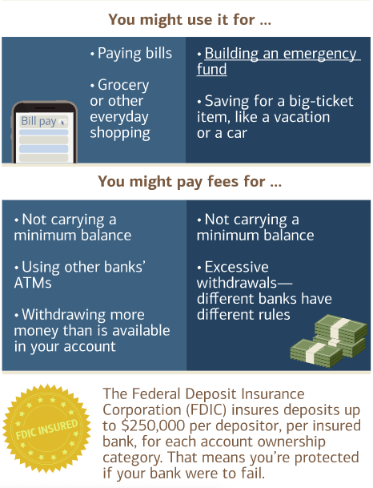

Part IV. Checking Accounts vs. Savings Accounts:

For each of the situations below, circle whether a Checking or Savings account is the better choice.

 | Scenario | Which account should they use?
a | Chris wants to put money aside so he can buy his mom a birthday present. | Checking | Savings
b | Sam wants to buy school supplies for a project she is working on. | Checking | Savings
c | Aisha wants to withdraw $20 from an ATM so she can buy a movie ticket and go watch the movie with her friends. | Checking | Savings
d | Neil rides his bike every day to school and back and is responsible for maintaining his bike. He wants to make sure he has money to fix or replace anything that might break in the future. | Checking | Savings
e | Rosa is going on a vacation with her parents in a few months and wants to put the money she just got from the holidays aside to buy souvenirs. | Checking | Savings

Part V. Talk about it:

Why do you think people use savings accounts?

What are some reasons why someone might not have a savings account?

Why do you think there is a limit on the number of times you can withdraw or transfer money in your savings account?

Why do you think it’s a good idea to have your money for savings in a different account than your checking account?

Your cousin is eager to start putting her money aside in a savings account since she just started her first job. What are THREE things you recommend she asks the bank teller (or researches) when she’s opening her savings account?

Note: This activity was adapted with permission from the NextGen Personal Finance Middle School Course MS-5.3.

