Comparison Shopping

Note to parents and caregivers:
This activity provides an overview on comparison shopping. Work through the sections of the activity and discuss the questions asked throughout together. You will need to search online to complete the section “Compare: Shop for the best sweatshirt”

Part I. Discussion: What would you do?
Consider what you would do in each of these two scenarios. Discuss your responses for each.

- Pretend your parent says they’ll buy you a new coat for winter. How will you decide which coat to buy?

- How (if at all) would your decision change if your parent said they’ll pay for half but you have to pay for the other half?

Part II. Infographic: Comparison Shopping
For a larger version visit: https://www.consumer.ftc.gov/articles/0041-shopping-online-infographic
Review the infographic below together. The information in the infographic will help you complete Parts III and IV.

If you’re buying something small, like a pack of gum, maybe you just reach for your favorite, buy it, and enjoy. But what should you do if you’re shopping for something more important or expensive? You’ll want to comparison shop by deciding which features you care about and finding the best option to meet your needs.

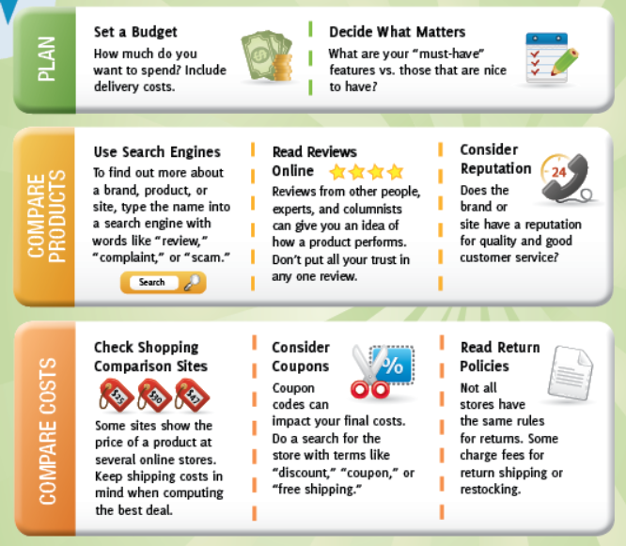
Source: Federal Trade Commission
Part III. Buying a Cellphone vs. Mac & Cheese
- First, pretend you’re going to buy a new cell phone. Using the descriptions above, write an X in the boxes in the first column below if you would do that step when buying a cell phone.

Second, pretend instead that you are trying to buy a box of mac and cheese at the grocery store. Put an X in the boxes in the second column if you would do that step when buying mac and cheese.
 | Cell phone | Box of mac & cheese
Set a Budget
Decide What Matters
Use Search Engines
Read Reviews Online
Consider Reputation
(cont from above) | Cell phone | Box of mac & cheese
Check Shopping Comparison Sites
Consider Coupons
Read Return Policies

Why would you take MORE steps when buying a cell phone than a box of mac and cheese?

Part IV. Compare: Shop for the Best Sweatshirt
The “Decide What Matters” box in the infographic asks, “What are your must-have features?” For this activity your must-have feature of the sweatshirt you are going to buy is that it has to be a black sweatshirt. Your job is to search online for 3 sweatshirt options that have your must-have feature and compare the sweatshirts together to choose which sweatshirt to buy.

Which sweat shirt would you buy if the price did not matter?

Which sweatshirt would you buy if you had to pay for it?

Is the sweatshirt you would buy with your own money, different than the one you would buy if the price did not matter?
If so, why?

What helped you decide what sweatshirt to buy?

How much did price influence your decision?

Part III. Talk about it

Why should you consider factors OTHER than just price when comparison shopping?

Give an example of an item (other than cell phone) where the must-have feature could be HOW WELL IT WORKS.

Give an example (other than clothes) where the must-have feature could be APPEARANCE.

