How Do You Budget?

Notes for parents and caregivers:

Part I. Draw a picture
Surprise - your grandma gave you $100 for your birthday! How do you divide this money to spend on things you need, things you want, and money for savings? Write down the percentage you would put in each bucket and then fill in the circle to create a pie chart that represents your breakdown below!
_______ % in Needs

_______ % in Wants

_______ % in Savings

Why did you choose to divide Grandma’s birthday present the way you did?

Part II. Video: Building a Budget

Use the link below to watch a video to answer the following questions
https://edpuzzle.com/media/5ff3b86c2128fc1412d451e8

Building a budget for the first time can seem overwhelming - but it doesn’t have to be! Watch this video to learn the basics of creating a budget. Then, answer the questions.

- All of the following options are considered a “need” EXCEPT…
  - Music streaming subscription
  - Gas for your car
  - Monthly health insurance premium
  - Rent
- All of the following options are considered “wants” EXCEPT…
  - Electricity and gas
  - New fall sweater
  - Eating at your favorite local restaurant
  - Netflix subscription
- Which of the following statements about saving is TRUE?
  - Saving is best for long-term goals only.
  - Setting aside money each month consistently will help you in the long run when future needs come up.
  - You should dedicate 20% of your income to computer upgrades each month.
  - Monthly expenses like utilities should be categorized under saving.

- Why is it helpful to track your spending for 2 months?
  - You can receive higher interest rates for your savings account when you can show how you spend your money.
  - You can receive special discounts at certain stores when you can show how you spend your money.
  - To identify your spending patterns and then prioritize your needs, wants, and savings goals.
  - To eliminate all spending on your wants.

Part IV. Video: Understanding Your Paycheck
Use the link below to watch a video to answer the following questions
https://www.youtube.com/watch?v=3fDrDZAqf-8

The previous video described how you can divide your money across multiple categories. Let’s take a step back to better understand where that money comes from in the first place - your paycheck! Watch this video to learn how to better read your paycheck. Then, answer the questions.

In your own words, explain the difference between gross pay and net pay.

Should you use gross pay or net pay when creating a budget? Why?

Part V. Read a Pay Stub
In the second video, we learned the basics of reading a pay stub. Now, it’s time to put that knowledge into practice! Use the sample pay stub below to answer the questions that follow.

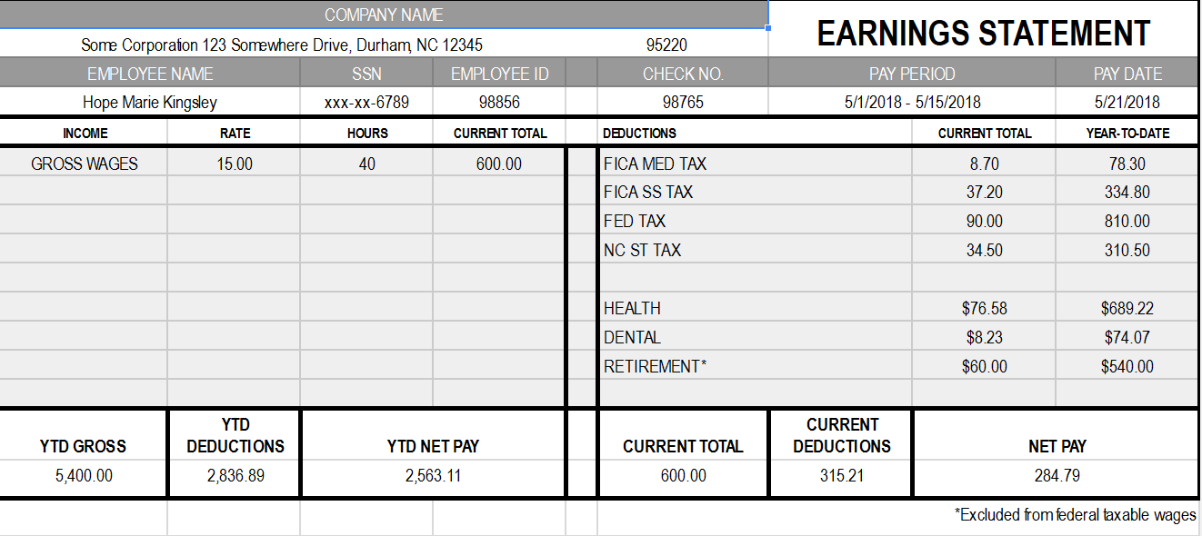

- What pay period is this pay stub for?
  - 5/1/18 - 5/7/18
  - 5/1/18 - 5/15/18
  - 5/15/18 - 5/21/18
  - 5/1/18 - 5/31/18

- When is Hope receiving this paycheck?
  - 5/1/18
  - 5/15/18
  - 5/21/18
  - 5/31/18

- How much does Hope get paid per hour?
  - $10
  - $15
  - $30
  - $40

- How many hours did Hope work this pay period?
  - 10
  - 15
  - 30
  - 40

- What was Hope’s gross pay during this pay period?
  - $78.30
  - $284.79
  - $600
  - $5400

- What was Hope’s net pay during this pay period?
  - $78.30
  - $284.79
  - $600
  - $5400

- How much did Hope pay in total in taxes during this pay period?
  - $8.70
  - $45.90
  - $90.00
  - $170.40

- How money was taken out in total deductions from Hope’s paycheck this pay period?
  - $284.79
  - $315.21
  - $540
  - $2836.89

- How much would Hope get paid in one month?
  - $284.79
  - $569.58
  - $600
  - $1200

- If she uses the 50/30/20 rule to budget, calculate how much money would go towards Needs, Wants, and Savings per month.

Part VI. Talk about it

Your friend gets his first job as a cashier at your local supermarket. He comes home and says, “Oh my gosh! I’m getting paid $8 an hour, so if I work 10 hours this week and next week, that means I’ll have $160 to spend!” Is this true?
What would you tell your friend?

Do you think creating a budget is helpful? Why or why not?

How would you explain budgeting to your friend?

Why would you create a budget?

What is the difference between needs and wants?

Why is it important to have part of your budget include savings?

Note: This activity was adapted with permission from the NextGen Personal Finance Middle School Course MS-3.3.

