Explaining the Importance of Equity in Family Engagement
Using Specific Examples
These examples were generated by participants during a “Reframing Institute” on February 16, 2021. For more tools for reframing, visit famengage.org.
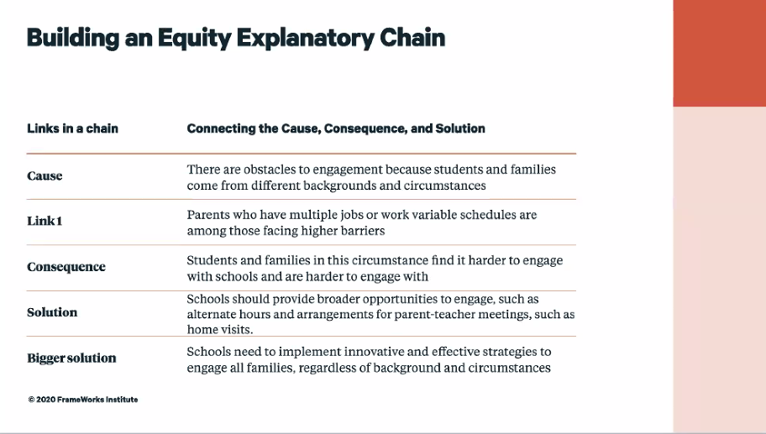
- Some families are not proficient in English but want their children to have the same opportunities as other students. Schools need to provide translation and interpretation of information sent home.
- Our Community Conversations are always hosted in English. For our upcoming Conversation about the things that worked and didn't work during the pandemic, we are calling non-English speaking parents and asking them the same questions to include their feedback. We have also hosted a Spanish Conversation, so translators were just for the district reps.
- Sometimes it is hard to come to meetings with the school because I have multiple young children. It's helpful when I can use virtual meetings so I don't have to get all my kids out of the house and keep them safe/occupied while I meet with the teacher. I think all families like me want to be engaged, but we need creative solutions and new opportunities. Working together, we can figure it out.
- Parent - Teacher Conferences are held for specific times once a quarter. We're offering virtual conferences so that families don't have to travel to the building to participate.
- Communication is really important. We have 1/2 of our families who speak a language other than an English. This is an issue for many. Recently, I started using an app that allows me to send messages to all families in their language. Our school motto is : The little school with a big heart. I try to live by that and always put myself in the families shoes.
- Solutions: multiple times for engagement, virtual options, transportation provided, childcare, working with the community to determine what inequities still exist and what barriers to overcome
- Communication is one of the keys to family engagement, link: 2 way communication is effective, consequence, when we only communicate one way we lose equity and access to all perspectives, solution: create spaces for 2 way communication with families (ex, Dojo, remind, notebook/journal, telephone calls)
- It's important to address obstacles to engagement, such as families who have limited access to transportation to attend school meeting and events. This can be difficult to engage these students and families with schools. We can utilize home visits or virtual meetings to help accommodate these families, or be flexible with our meeting hours.
- We have conducted parent meetings in Maya Kanjobal, Maya Mam and Spanish and addressed 1 topic at a time with opportunity for questions.
- Events for families held at the school in a school night are not well attended. Many families are working in the evenings or caring for family members. These families don't have the opportunity to learn all of the information we share at the school events. So, we are going to live stream the event, create a short video and post it on our website and FB. We are also going to send home the same information in print - in Spanish too. This way all of our families should be able to have access to the information we have for them.
- Perspective is interesting. When we hear the word EQUITY versus inequality, it often brings a very different mindset to the conversation. One is primarily thoughts of race and/or gender. However, some of us that are in the EQUITY movement include Handicap, zip code, voice inflection and much more. It is a BIG topic.
- Some students have obstacles that inhibit them from succeeding to their fullest. Parents are stretched to their limits. If we can meet them creatively where they are and take them from there, the educational rocket can launch.
- There is often a disconnect between schools and families due to trust issues. Solution, teachers need to reach out to parents with texts. emails, and/or phone calls that are positive conversations rather than only contacting them personally if there is a problems.
- Link: Children whose parents who have substance abuse issues, suffer from undiagnosed mental health issues, systemic and generational norms that interfere are among those facing higher barriers. Why? Mentally, parents are so overwhelmed with life they can't mentally process anything else. It's just something else to deal with. Schools and school districts need knowledge and access of community resources available to support children in these circumstances. Partnerships need to be created where children can be referred to get what they need whether it's extended family, church or community organization.

