Human Trafficking Stability Assessment Training
Wednesday, February 12, 2020
9:00 AM – 12:00 PM
Agenda
1. Introductions
2. Review Stability Assessment Tool
- History
- Purpose
- Specific Goal
- Recent Revisions
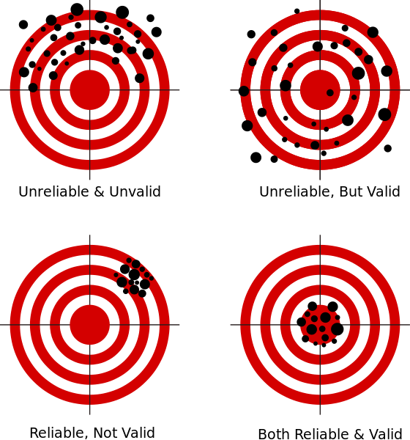
3. Learn about Reliable Ratings Using the Stability Assessment Tool
- Do we regularly rate survivors the same way on the stability assessment, given the same information about their life?
- Are our ratings representative of their current life state in a particular domain?
4. Practice Time
- Review and rate up to 4 cases
- Compare ratings using the inter-rater reliability worksheet
- Discuss results as a group
5. Evaluate and Depart
- Visit go.osu.edu/feb2020 and complete a brief evaluation

