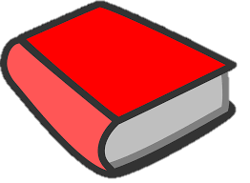
Partnerships for Literacy
Sample Ohio School Action Steps
for Family and Community Engagement for Language and Literacy

Priority Area #1: Communication/Community Partnerships/Learning at Home
Action Step | Description  How much, how often and with whom? | Who will be impacted | How will you know if you’ve achieved success? What data will be used?
A newsletter with general literacy information, grade level activities and descriptions of student progress terms will be developed for families. | The ELA Advocate will develop the newsletter in collaboration with teachers and Principal monthly  The newsletter will be sent home with students, posted on the school website and sent digitally to families.  The first newsletter will be sent at the end of September. | Families will be able to access literacy information that pertains to their students | Baseline survey results will be reviewed every 6 months – completed by teachers and parents at December and April P4L meetings.
The newsletter above will be sent to community partners (i.e. preschools, library, summer programs, YMCA) | Copies of the newsletter PLUS an introductory letter on direction for posting the newsletter will be sent to target community partners. | Families of potential students and other community members will have information regarding literacy
Each classroom teacher will select and send home a “bag of books” for each student, based on their literacy level. (Decodable text, pleasure book and Zone of Proximal Development level book) | Teachers will select “bags of books” for students to read at home. A recording sheet will be sent for families to note when each book is read and the literacy level. Teachers will review all received recording sheets and report quarterly on progress. | Each student at the school will have access to books at home | Recording sheets will be reviewed quarterly for number of students participating AND who returned recording sheets

