Parent-Teacher Partnerships for Student Success

What is the Model?
Parents and teachers meet together to learn how to strengthen their partnership to support student success. Parent and teacher co-facilitators lead discussions and interactive activities aimed at building parent and teacher confidence and understanding of effective strategies for partnering. In addition, Building and District Leadership Teams learn how they can improve their partnership practices.

8 Sessions
Session topics are based on:
- Six key areas of the School, Family and Community Partnerships Framework from Johns Hopkins University: parenting, communicating, volunteering, learning at home, volunteering, decision-making, collaborating with the community and;
- Seven principles of partnerships from the work of Ann and Rud Turnbull of the University of Kansas: communication, competence, respect, commitment, equality, advocacy, and trust.

District Responsibilities
- Recruit a parent and a teacher to be co-facilitators. Parent may be a Parent Mentor or other parent who has demonstrated a vested interest in success for all students. The teacher should be leader who models respect for families and who values family engagement.
- Work with the SST Coach and co-facilitators to develop and implement a recruitment plan for parents and teachers to attend the training.
- Dedicate resources such as space, time, etc. to support the implementation of the training sessions.
- Meet regularly with the co-facilitators and the SST Coach to remain up to date on the progress of the Parent-Teacher Partnerships sessions.
- Develop a feedback loop to share lessons learned between the DLT, BLT and the Parent-Teacher Partnerships group.
- Over the two-year period, plan and facilitate eight, 1.5 hour Parent-Teacher Partnership meetings for combined audiences of parents and teachers.
- Participate in five, one-hour webinars over two years. Webinars can be viewed after school hours.
- Communicate regularly with school administrators about the progress of the Parent-Teacher Partnerships group.
- Work with school administrators to establish a feedback loop from the parent-Teacher Partnerships group to the DLT and BLT.

SST Responsibilities
- Provide coaching/support to co-facilitator team
- Monitor session fidelity

Models of Implementation

District-Wide
- Parent and teacher pairs from multiple schools participate
- Feedback link to BLT and DLT

Single-Building
- Parents and teachers from a single school participate
- Feedback link to BLT

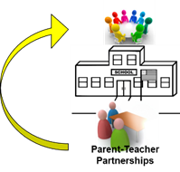
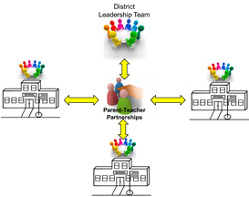
Contents were developed under a grant from the US Department of Education, #323A120002-13 and adapted in 2017 by The Ohio State University. However, the contents do not necessarily represent the policy of the US Department of Education, and you should not assume endorsement by the Federal Government. Project Officer, Jennifer Coffey. PTP Documents Archive: https://u.osu.edu/familyschoolpartnerships/ptp/

