Parent-Teacher Partnerships for Student Success

Turnbull’s Arch Activity Instructions for Facilitators

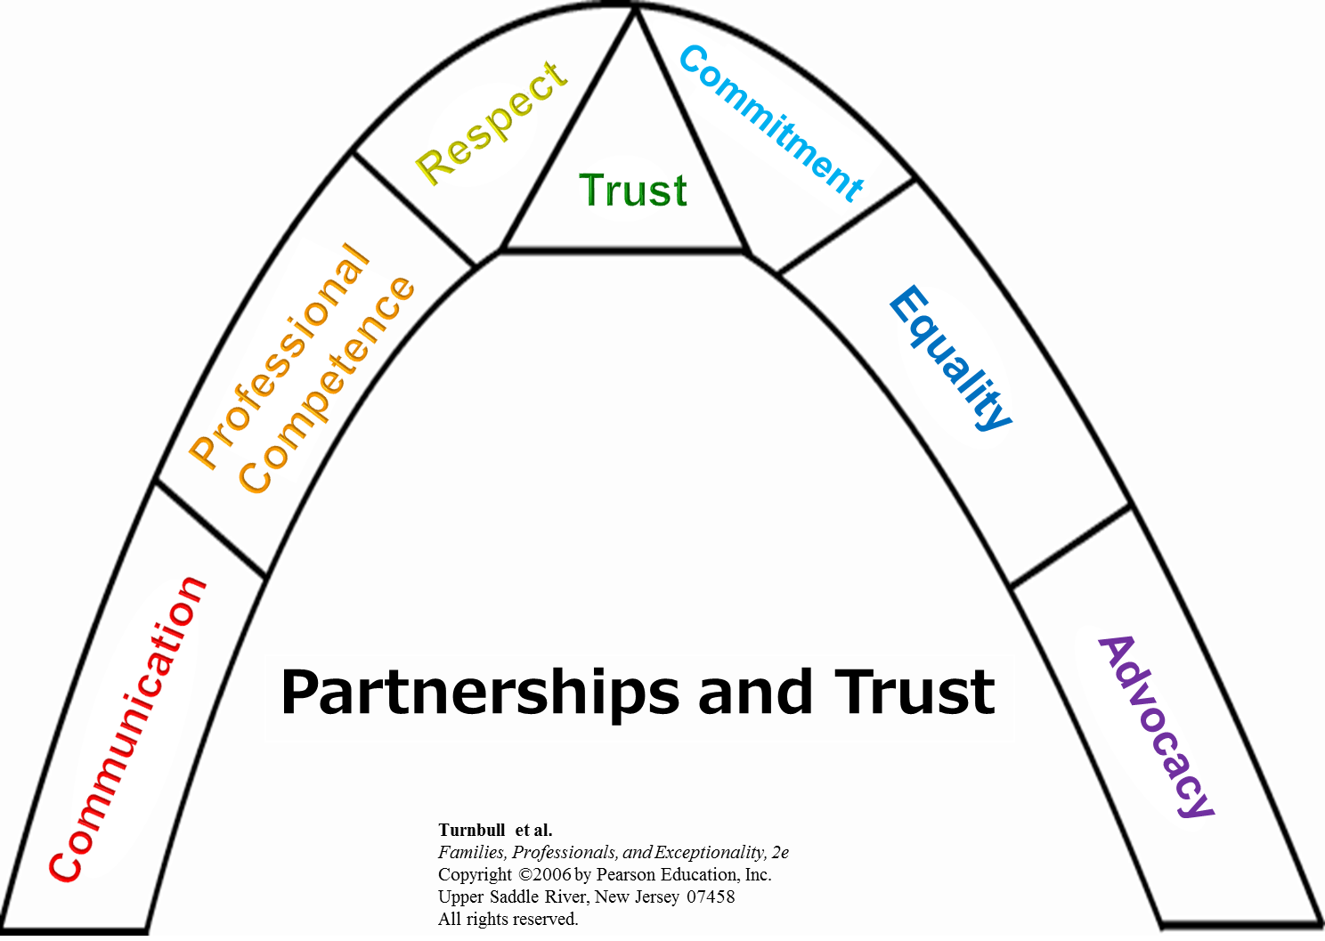
Review the Principles of Partnership in this arch: Communication, Professional Competence, Respect, Commitment, Equality, Advocacy, and Trust. TRUST is connected to and holding together the other 6 principles. "Unless connected by trust, partnership is in jeopardy" (Turnbull, et al., 7th ed., p. 183). Draw an arch on a poster with all areas, except Trust - that will be on another paper cut out as a triangle. List activities / strategies that your group has demonstrated working together in these areas. If you feel that you have developed Trust - write some of those ways on the triangle and place it on the arch - if it is beginning to develop - put just some of the triangle on the arch.

