Partnerships for Literacy

Documents in this Series

Building your school’s Partnerships for Literacy Team (P4L)
Family & Community Engagement for Early Literacy Inventory

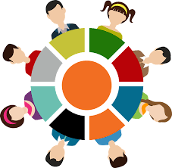

Focused Discussions with Families

Creating a School Plan for Family and Community Engagement for Language and Literacy

