Parent-Teacher Partnerships Model

State Personnel Development Grant (SPDG) of Ohio

What is the Model?
Parents of children with disabilities and teachers meet together to learn how to strengthen their partnership to support student success. Parent and teacher co-facilitators lead discussions and interactive activities aimed at building parent and teacher confidence and understanding of effective strategies for partnering. In addition, Building and District Leadership Teams learn how they can improve their partnership practices.

8 Sessions
Session topics are based on:
- Six key areas of the School, Family and Community Partnerships Framework from Johns Hopkins University: parenting, communicating, volunteering, learning at home, volunteering, decision-making, collaborating with the community and;
- Seven principles of partnerships from the work of Ann and Rud Turnbull of the University of Kansas: communication, competence, respect, commitment, equality, advocacy, and trust.

SPDG District Responsibilities
- Recruit a parent of a student with a disability and a teacher to be co-facilitators. Parent may be a Parent Mentor or other parent who has demonstrated a vested interest in success for all students. The teacher should be leader who models respect for families and who values family engagement.
- Work with the SST Coach and co-facilitators to develop and implement a recruitment plan for parents of students with disabilities and teachers to attend the training.
- Dedicate resources such as space, time, etc. to support the implementation of the training sessions.
- Meet regularly with the co-facilitators and the SST Coach to remain up to date on the progress of the Parent-Teacher Partnerships sessions.
- Develop a feedback loop to share lessons learned between the DLT, BLT and the Parent-Teacher Partnerships group.

Co-facilitators Responsibilities:
- Attend five train-the-trainer sessions in Columbus, Ohio over a two-year period from September, 2015 through May, 2017.
- Over the two-year period, plan and facilitate eight, 1.5 hour Parent-Teacher Partnership meetings for combined audiences of parents and teachers.
- Participate in five, one-hour webinars over two years. Webinars can be viewed after school hours.
- Communicate regularly with school administrators about the progress of the Parent-Teacher Partnerships group.
- Work with school administrators to establish a feedback loop from the parent-Teacher Partnerships group to the DLT and BLT.

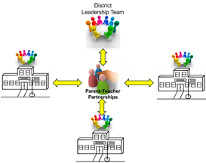
Models of Implementation
Single-Building  - Parents and teachers from a single school participate  - Feedback link to BLT | 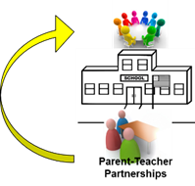

District-Wide
- Parent and teacher pairs from multiple schools participate
- Feedback link to
BLT and DLT

SST Responsibilities
- Attend train-the-trainer sessions in Columbus and webinars with the district co-facilitator team.
- Provide coaching/support to co-facilitator team
- Monitor session fidelity.
- Assist district co-facilitators with reporting progress to the state Project Coordinator.
- Assist district co-facilitators with timely reimbursement of parent participants.
- Facilitate compensation to teacher co-facilitator for substitutes, travel, and time for planning and facilitation.

In partnership with:
- The Ohio Department of Education, Office for Exceptional Children
- Bowling Green State University, College of Education and Human Development
- The Ohio Coalition for the Education of Children with Disabilities
- The Ohio State University, College of Education and Human Ecology, CETE

Ohio’s State Personnel Development Grant
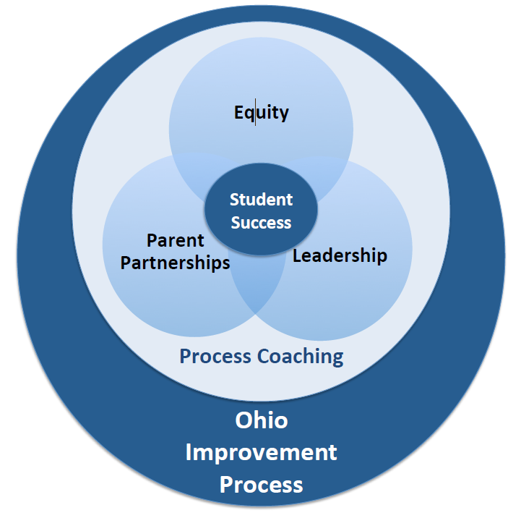

The contents of this report were developed under a grant from the U.S. Department of Education, and you should not assume endorsement by the Federal Government. Project Officer, Jennifer Coffey.

