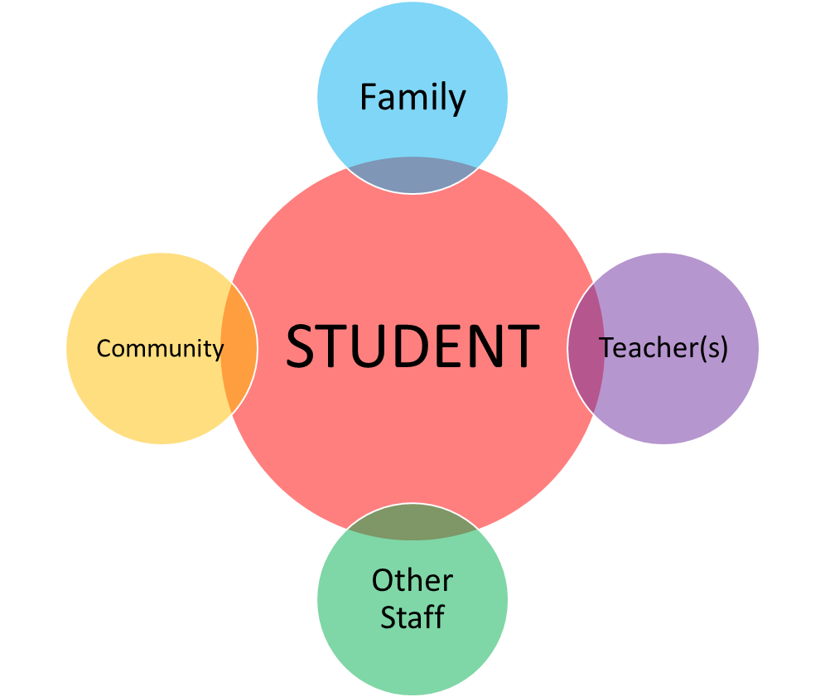

**PARENT-TEACHER PARTNERSHIPS for STUDENT SUCCESS!**